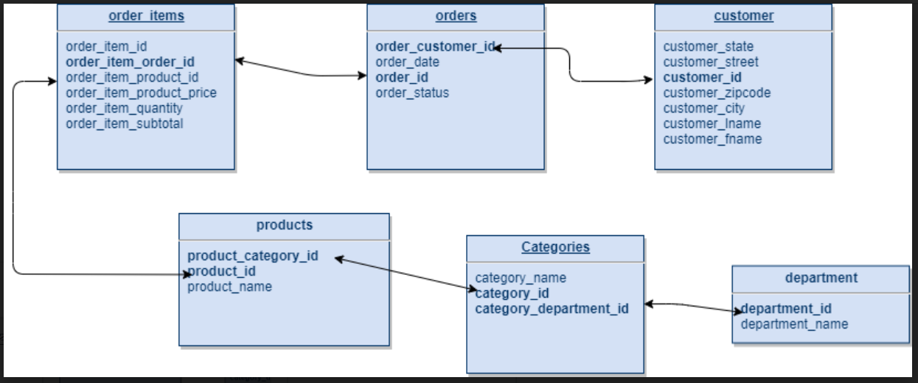

**\*\* Question 1 – Find top 5 states that generated most number of orders?**

**\*\* Question 2 - Find top 2 product categories (by sales amount) in each city (cities that have more than 100 consumers)**

**The marketing team wants to launch a campaign and wants to find out the top 2 most popular product categories (by sales amount) for each city that has more than 100 consumers**